The Treasures of the Kingdom
  - Jesmond Park Uniting Church ~ 10 August 2025
… a flourishing, inclusive and life-affirming church,
blessing our communities and our environment
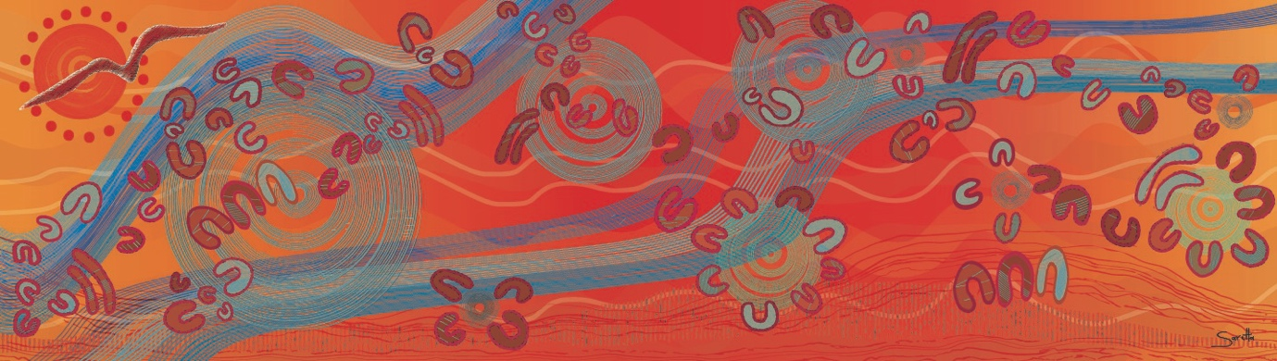

Welcome and Acknowledgment of Country
We acknowledge the Awabakal Peoples of the land on which we gather, and pay respects to Elders past, present and emerging.
In the light of Christ, we affirm our covenant to walk together
towards truth, justice, and reconciliation.

Call to Worship: John 6:35
Jesus said:
‘I am the bread of life.
Whoever comes to me will never be hungry,
and whoever believes in me shall never thirst.’
When we are parched: God refreshes.
When we are hungry: God sustains.
When we are naked: God covers.
When we are barren: God provides.
O God, you are our God: we seek your face.
Every thirst may be quenched in the waters of God.
Every hunger may be fed at the table of God.
Let us worship God.

Together in Song 107: Sing Praise and Thanksgiving
Sing praise and thanksgiving, let all creatures living
now worship their maker with gladness and song;
all glory and honour we come to him bringing:
O praise to the Almighty, sing praise to our God.
Our lives of his making he brings to their waking;
in darkness he held us in his gracious care,
now into the light we are called from our sleeping:
O praise to the Almighty, sing praise to our God!
Lord, frame our desiring to do your requiring,
that unto your glory be all that we do;
and where we have faltered, give strength and give healing:
O praise to the Almighty, sing praise to our God!
Prayer of Invocation
Come, Holy Spirit, wind of God, cool us as breeze,
blow among us and around;
open our ears to hear the truth, and our mouths to cry out
in praise of the Living One, Jesus Christ our risen Saviour.
Amen.
Come, Holy Spirit, living water, Giver of life,
that we may drink in the word, and taste the bread of life;
help us to understand one another,
and to speak one another’s language.
Keep us in union with Christ in all our worship.
Amen.
Come, Holy Spirit, fire of God, come,
and burn the chaff of our lives
that we may bear the fruit of love;
come, increase in us your gifts for the good of your Church,
and make us one body for the sake of Jesus our liberating Lord.
Amen.

Passing the Peace
The peace of our Lord Jesus Christ be with you.
And also with you.

Ministry of the Word

Luke 12:32-34
Do not be afraid, little flock,
for it is your Father's good pleasure to give you the kingdom.
Sell your possessions and give alms.
Make purses for yourselves that do not wear out,
an unfailing treasure in heaven,
where no thief comes near and no moth destroys.
For where your treasure is, there your heart will be also.

Matthew 13:44-46
“The kingdom of heaven is like treasure hidden in a field.
When a man found it, he hid it again,
and then in his joy went and sold all he had and bought that field.
Again, the kingdom of heaven is like a merchant
looking for fine pearls.
When he found one of great value,
he went away and sold everything he had and bought it.

Sermon: Where is your Heart?
In our struggle to hear your word, O God,
bless even our doubts, our wonderings,
our wanderings, our soul-struggles,
life’s deep questions, and deeper mysteries.
Teach us to love our questions as well as our answers.
Amen.

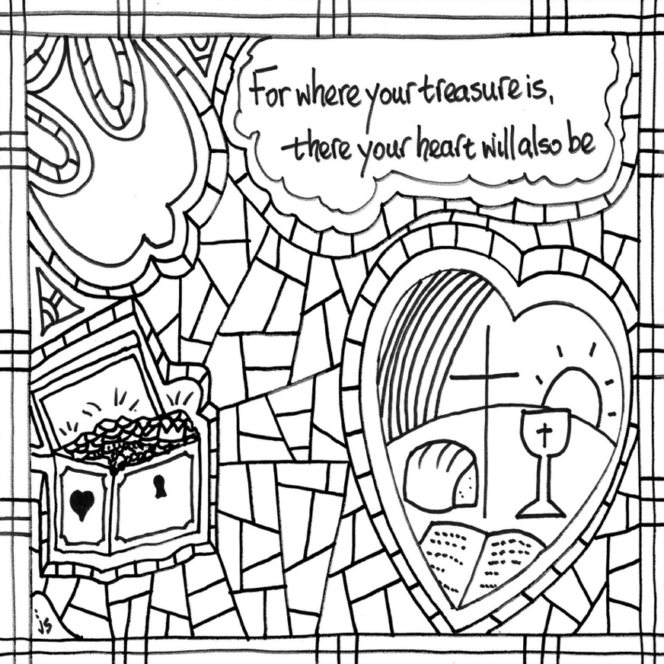
Affirmation of Faith
We are not alone, we live in God’s world.
We believe in God: who has created and is creating,
who has come in Jesus, the Word made flesh,
to reconcile and make new,
who works in us and others by the Spirit.
We trust in God.
We are called to be the Church:
to celebrate God’s presence,
to live with respect in Creation,
to love and serve others,
to seek justice and resist evil,
to proclaim Jesus, crucified and risen,
our judge and our hope.
In life, in death, in life beyond death,
God is with us.
We are not alone.
Thanks be to God.

Prayers of the People

Offering and Doxology (Tis 768)
Praise God, from whom all blessings flow;
Praise Him, all creatures here below;
Praise Him above, ye heavenly host;
Praise Father, Son, and Holy Ghost.
Amen.

Sacrament: Holy Communion
Blessed are those who hunger and thirst for righteousness,
for they shall be satisfied.
Matthew 5:6

The Prayer of Thanksgiving
The eternal God be with you.
And also with you.
Lift up your hearts.
We lift our hearts to God.
Let us give thanks to God who is Wisdom and Love.
It is right to give our thanks and praise.
It is always right in all times and all places
to give thanks to God, Holy Wisdom and Eternal Love.
Holy and life-giving God, we offer you thanks and praise
in wonder and awe, in delight and astonishment:
for you are Creator of all things, and Lover of each one.
You sculpted the planets and set the stars on fire.
You moulded the Barrington Tops
and shaped the ways of the Hunter River.
You imagined the echidna into being
and set the corellas squawking.
You made the Humpback whales of the oceans
just for the pleasure of them;
and you called forth human beings
that we might love and care for your creation as you do.
The rainbow and the law are signs
of your promise to protect the earth,
and your covenant with a people called to witness to the nations.
When we failed to honour your work and your being,
your Word of Wisdom entered creation as Jesus
to share with us the joy and pain of our humanity.
Through Christ, life rises from despair.
In Christ, all things are made new.
Because of Christ, your Spirit remains with us.
As she once brooded over the waters of the deep,
your Spirit now works throughout creation,
preparing for the day when all things find their purpose in you.
Therefore, with the whole creation:
with all your people gathered across time and space,
with all the works of your hands
with everything visible and invisible, imagined and unimaginable,
we sing in thanks and praise:
Hosanna, hosanna, hosanna in the highest!
Lord, we lift up your name with our hearts full of praise,
be exalted, O Lord our God,
hosanna in the the highest!
Blessed is Jesus, Wisdom embodied, who feasted with sinners, disciples, friends and now shares this meal in our midst.
On the night before Jesus died, on the evening of betrayal,
Jesus took bread, gave thanks, broke it and said:
‘This is my body which is for you. Do this in memory of me’.
In the same way, also the cup, after supper saying:
‘This cup is the new covenant in my blood.
Do this, whenever you drink it, in memory of me’.
As we eat this bread and drink this cup,
we proclaim the coming of God’s new creation
in and through the life, death and resurrection of Jesus
and finally, in the completion of all things
when Christ comes again:
Christ has died.
Christ is risen.
Christ will come again.
Send your Holy Spirit, O God, that these gifts in creation
may also be for us the gift of re-creation in Christ.
Shape us into one body; press us into one wine;
bake us into one bread – the Bread of Life and Cup of Liberation –
for the feeding of all your children and the nurture of creation.
Through Christ, with Christ, in Christ
in the power of the Spirit of Love,
all glory be to you, O God, Source of All Being,
Eternal Wisdom and Holy Spirit
as it was in the beginning is now and ever shall be.
Amen.

The Breaking of the Bread
Christ is the bread of life,
food for healing and wholeness.
Christ is the cup of hope,
wellspring of resurrection life.
The gifts of God for the people of God.
May we who share these gifts be found in Christ and Christ in us.
Notices and Community Life

Sending Forth
God, who is love, fill your hearts.
Christ Jesus, who is the new life, inspire your hopes.
The Holy Spirit, who is lifegiver, spur you to deeds of compassion.
Go in the power of God’s good Spirit:
with the gentle fire of God’s zeal,
with the soothing water of peace,
and with the breath of life,
ready to work for justice and peace.
We go in Christ’s name. Amen.

Together in Song 547: Be thou my Vision
Be thou my vision, O Lord of my heart,
naught be all else to me, save that thou art
thou my best thought, by day or by night,
waking or sleeping, thy presence my light.
Be thou my wisdom, be thou my true word;
I ever with thee and thou with me, Lord;
thou my great Father, thy child let me be;
thou in me dwelling and I one with thee.
Riches I scorn and the world’s empty praise,
thou my inheritance, now and always;
thou and thou only the first in my heart;
high King of Heaven, my treasure thou art.
High King of heaven, after victory won,
may I reach heaven’s joys, O bright Heaven’s Sun!
Heart of my own heart, whatever befall,
still be my vision, O ruler of all.

References: Bulletin Art by Stushie Art
Unting in Worship II

